**Bottom View of Binary Tree:-**

Given a binary tree, print the bottom view from left to right.  
A node is included in bottom view if it can be seen when we look at the tree from bottom.

                      20  
                    /    \  
                  8       22  
                /   \        \  
              5      3       25  
                    /   \        
                  10    14

For the above tree, the bottom view is 5 10 3 14 25.  
If there are **multiple**bottom-most nodes for a horizontal distance from root, then print the later one in level traversal. For example, in the below diagram, 3 and 4 are both the bottommost nodes at horizontal distance 0, we need to print 4.

                      20  
                    /    \  
                  8       22  
                /   \     /   \  
              5      3 4     25  
                     /    \        
                 10       14

For the above tree the output should be 5 10 4 14 25.

**Example 1:**

**Input:**

1

  / \

  3 2

**Output:** 3 1 2

**Explanation:**

First case represents a tree with 3 nodes

and 2 edges where root is 1, left child of

1 is 3 and right child of 1 is 2.

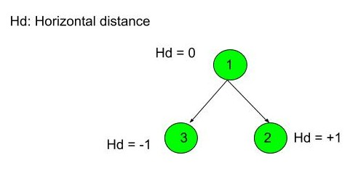

Thus nodes of the binary tree will be

printed as such 3 1 2.

**Example 2:**

**Input:**

10

  / \

  20 30

  / \

  40 60

**Output:** 40 20 60 30

**Your Task:**  
This is a functional problem, you **don't**need to care about input, just complete the function **bottomView**() which takes the root node of the tree as input and returns an array containing the bottom view of the given tree.

**Expected Time Complexity:**O(N).  
**Expected Auxiliary Space:**O(N).

**Constraints:**  
1 <= Number of nodes <= 105  
1 <= Data of a node <= 105